**ASP.NET Entity Framework Task** 22.01.2023

Note: Create new folder “ASP.NET Entity Framework” contains file in your repo with the bellow:

1. Create customer table that contains information the bellow info:

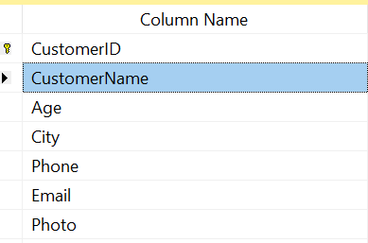

1. Create table City that contains information reference to the city column in customer table.
2. Create asp.net web from that Allow the Admin to create new Customer.
3. Create web form that include:
   1. All data with the name of City rather city ID
   2. Number of customers
   3. Avg of age
   4. Max Age
   5. Search box with the Customer ID and Customer Name.

Note: You must use bootstrap in your Web Form